Task 3 Report: Real-Time Web Searching in n8n using SerpAPI and Tavily

# 1. Introduction

The goal of this project is to integrate real-time web search capability into an agentic AI system using the n8n workflow automation platform. Leveraging APIs like SerpAPI and Tavily, we built a framework that mimics the reasoning flow of platforms like Perplexity.ai, where the system not only performs a search but also delivers relevant, natural-language answers based on real-time web data.

# 2. Framework Overview

We implemented two parallel workflows:  
  
SerpAPI Agentic Flow:  
(OpenRouter Chat Model, Simple Memory, SerpAPI Tool, AI Agent)  
  
Tavily Direct Response Flow:  
(HTTP Request to Tavily API, Direct summarized response, Minimal post-processing)  
These workflows enable both structured agentic reasoning and direct factual response to user queries.

# 3. Purpose of the Report

This report compares SerpAPI and Tavily, evaluates the web-search-based reasoning workflow, and assesses their performance within an n8n agentic flow context.

# 4. Features Comparison

SerpAPI:  
- Cloud-hosted API: Yes  
- Dockerized support: No  
- GUI/visualization: Yes (via n8n)  
- Summarized answers: No (only URLs/snippets)  
- Free trial: Very limited  
- Emoji usage: Not supported

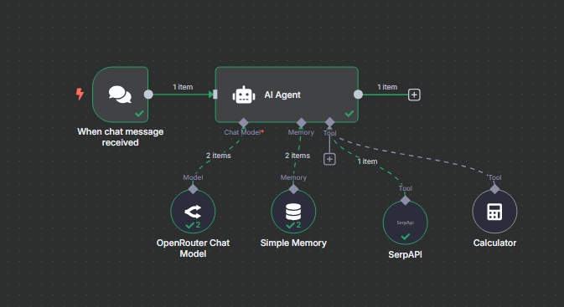  
  
Tavily:  
- Cloud-hosted API: Yes  
- Dockerized support: No  
- GUI/visualization: Yes (via n8n)  
- Summarized answers: Yes  
- Free trial: Generous  
- Emoji usage: Supported if manually added

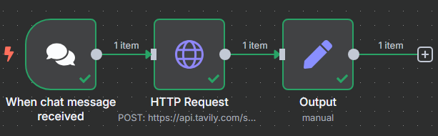

# 5. Commercial License Details

SerpAPI: Usage-based pricing, limited trial, commercial use allowed, stricter licensing terms.  
Tavily: Developer-friendly, generous free tier, commercial use allowed.

# 6. Memory Management

SerpAPI Workflow: Built-in memory via Simple Memory in n8n, session storage, and user memory support.  
Tavily Workflow: Requires manual memory setup; less integrated than SerpAPI.

# 7. Web Search Tools

SerpAPI: Wide configuration options, raw data returns, high flexibility.  
Tavily: Minimal setup, summarized factual data, high performance in direct response scenarios.

# 8. Documentation and Code

SerpAPI: Good documentation, version-controlled, supports documentation in n8n.  
Tavily: Simple documentation, GitHub presence, supports basic code annotation.

# 9. Toolkits and APIs

SerpAPI: Prebuilt toolkit with high ratings, strong API support, basic observability through n8n logs.  
Tavily: Lightweight but focused API, easy integration, compatible with monitoring tools.

# 10. Workflow Analysis

n8n supports visual logic, branching, and modular design, allowing complex agentic workflows to be created and tested with tool-chaining and conditional flows.

# 11. Reasoning and Thinking Tools

Framework supports LLM reasoning, memory-enhanced prompts, dynamic tool selection, and summarized output generation.

# 12. Conclusion

Tavily is recommended for summarized factual answers, while SerpAPI is better for granular data.  
n8n proves to be a robust platform for integrating memory, reasoning, and web tools in a unified workflow.

# 13. Recommendations for Further Exploration

- Add summarization for SerpAPI  
- Use browser-based search tools  
- Implement dynamic routing logic  
- Integrate observability tools for monitoring and performance optimization

# 14. Detailed Feature Comparison: SerpAPI vs Tavily

|  |  |  |
| --- | --- | --- |
| Feature | SerpAPI | Tavily |
| Cloud-hosted API | Yes | Yes |
| Dockerized Version | No | No |
| n8n Integration | Yes (via HTTP/Tool Node) | Yes (via HTTP Node or Plugin) |
| Search Result Type | Raw search engine results (URLs, snippets) | Summarized, concise answers |
| Summarization | No (requires post-processing) | Yes (built-in AI summaries) |
| Speed | Fast (Google/Bing backend) | Fast |
| Search Accuracy | High, depends on query and engine | High, focused on Q&A accuracy |
| Free Trial | Limited usage, low quota | Generous free tier |
| Commercial Licensing | Strict, usage-based | Flexible, dev-friendly |
| Memory Integration | Yes with agent memory tools | Manual integration required |
| Use Cases | Granular and structured web data | Summarized factual answers |
| Customization | Highly configurable | Minimal config needed |
| Output Format | Raw metadata + links | Clean readable text |
| Observability | n8n logs only | n8n logs only |
| Documentation | Google-style, complete | Simple and use-case driven |
| Toolkits/APIs | Comprehensive | Lightweight but efficient |

In this project, SerpAPI and Tavily were integrated to evaluate their strengths and limitations in real-time search tasks. SerpAPI connects to traditional search engines like Google or Bing and returns structured data such as URLs, snippets, and metadata. It is highly configurable but lacks built-in summarization. This means it is more suitable when raw data is needed, but an additional LLM is required to generate readable answers.  
  
On the other hand, Tavily is designed specifically for question answering. It directly returns summarized, human-readable answers with very little configuration. This makes it more efficient for Perplexity-style flows where concise and relevant answers are expected.  
  
Overall, Tavily is ideal for developers seeking plug-and-play solutions for real-time factual Q&A, while SerpAPI suits power users who need greater control over search behavior and output structuring.